|  |  |
| --- | --- |
|  |  |

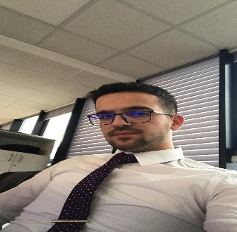 Mirjon Berisha

*Address: Prishtine, st.Muharrem Fejza Birthday :06.05.2000*

*prishtine, Kosovo Birthplace:Gjakova*

*Phone:+38345413546 Martial Status: Sigle*

*e-mail: berishamirjon27@gmail.com*

***Education***:

* Natyral Science Gymnasium Hight School “Hamdi Berisha” , Malisheva
* Actually I am a Student of third year of studies in Economic Faculty/Bank&Finance to “University of Prishtina” in Prishtina
* Student of Programming “PROED” Profesion School

***Job Experience:***

* Volunteer in Youth Center of Malisheva (2016-2018)
* Firmma “Termoklima” – Malisheva, central heating (2017-2019)

***Additional knowledge :***

* Languages:

Member languages: Albanian Language

Foreign language: English Language – Good

I followed three months of training at the BPB-Academy and after that I was employed as an assistant in the credit administration department, since September.

Special courses:

Programming on Software Engineery (Java)

***Computer***:

* Computer skills : Windows XP ,Microsoft Office(Word , Excel , Power Point , Access ,Outlook ) & Internet; Notepad ; Java ; Software Engineery
* Interpersonal skills : Abilities for working in group , collaboration etj.
* Communicative personality, with the working skills,sustainable ,atractive , and serious.